

INFORMATION FOR MARPOL SERVICE USERS

This Plan will be in effect from its approval by the Board of Directors of Santander Port Authority. However, modifications can be made within this period.
The agent must give a copy of these instructions, in English and Spanish, to the captains of ships which approach the Port of Santander.
- PORT FACILITIES FOR RECEPTION OF SHIP AND CARGO WASTE.

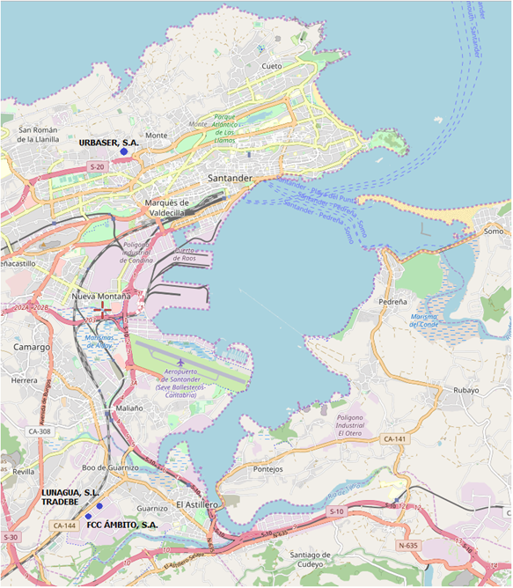

Companies authorized to provide waste reception facilities for ship and cargo waste in any of the berths of the Port of Santander, are:

LUNAGUA, S.L.-TRADEBE
Polígono Industrial de Guarnizo, parcela 84
39611 Guarnizo (Cantabria)
Tfno.: 942558096 - Fax: 942542376
e-mail Manager Department: jose.pavon@tradebe.com
e-mail Administration Department: ignacio.perezdelmolino@tradebe.com
FCC ÁMBITO, S.A.
Polígono Industrial de Guarnizo, parcela 97
39611 Guarnizo (Cantabria)
Tfno.: 942.559.729 - Fax: 942.559.737
e-mail Comercial Department: vjsainzp@fcc.es
e-mail Administration Department: gceballosma@fcc.es
URBASER, S.A.
Calle Repuente Nº 36
39012 Santander (Cantabria)
Tfno.: 942.355.246 y 942.331.800 - Fax: 942.341.714
Responsable of the service: magonzalez@urbaser.com
Administration Department: fjlavin@urbaser.com
Operations: mmontes@urbaser.com y limpiezapuertosantan@urbaser.com
- SHIP AND CARGO WASTE
Delivery of ship waste in the port of Santander is the following:
- Marpol, Annex I type C: waste from the bilges of the engine or fuel purification elements and engine oil from ships.
- Marpol Annex V: solid waste from ships and cargo, dunnage, packaging, strapping, etc.
- WASTE DELIVERY PROCEDURE
The classification of waste to be delivered is essential to its correct management in the port after delivery.
The companies authorized to receive Marpol waste guarantee service in all the docks, 24 hours a day, 365 days a year.
Notification of ship waste
The shipping agent, ship owner or the captain of the ship calling at the Port of Santander, must notify the Harbour Master and Port Authority of the quantity and type of Marpol waste to be delivered and/or the quantity to remain on board, as well as maximum storage capacity.
The format specified in Annex II of the Royal Decree 1084/2009 “Modelo de notificación antes de entrar al Puerto de destino” or in Annex V of the Royal Decree 1084/2009 “Modelo de notificación reducida para embarcaciones de pesca y deportivas de recreo” is used for this purpose. Both formats are attached to this Plan in the appendices. The notification shall be made 24 hours before the arrival of the ship in port. This does not include the exceptions specified in article 6 of the Royal Decree 1381/2002.
In the waste notification format presented in the “Permission to approach request”, ships must state whether, among Annex V waste to be discharged into the harbour, there is kitchen waste containing animal products from non-EU countries. This kitchen waste is subject to Regulation (EC) No 1069/2009 of the European Parliament and the Council of 21 October 2009, establishing health rules concerning animal by-products and by-products not intended for human consumption. Ships must make this statement in the notification form in Annex II of the Royal Decree 1084/2009 and inform the company providing the service.
The Harbour Master must immediately inform the Port Authority about authorizations to vessels not to deliver waste, to deliver all waste and the Certificates of exemption to deliver waste.
Fishing vessels and pleasure boats with authorization for up to twelve passengers must fill in the simplified version of the notification form as specified in annex V of this Plan, according to the following norms:
- All vessels based in the Port of Santander, must report to the Harbour Master´s Office every three months on delivery of all types of waste to a company authorized to provide waste reception facilities.
- Vessels from foreign ports or international fishing waters must fill in the simplified version of the notification form on arrival at the Port of Santander when this is the first port of call in Spain.
Request for waste reception services.
The Agent, ship owner or the ship´s captain must request the waste reception service directly from an authorized company with 24 hours notice. This request must indicate the time the vessel will be prepared for delivery. However, the authorized company reception facility will try to deal with requests within a shorter timeframe.
All necessary data will be given to the authorized company by telephone, fax or internet.
The ideal time for collecting the waste will be agreed on via this communication.
Every effort will be made to avoid unnecessary delays to the vessel or hinder other operations of the vessel in the port. Any losses caused by said delays will be reported to the Port Authority.
Data required for the provision of service by the authorized company:
- Type and amount of waste to be received.
- Quay
- Ship data (Port of call, name of vessel, flag, GT)
- ETA
- ETD
- Limitations and particular circumstances of the service (The vessel uses its own pumps or requires the use of the authorized company´s pumps)
Provision of service
Once the provision of service is confirmed, the company authorized to receive waste has the human and material resources to provide the service, according to agreed conditions.
Marpol Annex I, II and V (cargo residues) waste must be stored in the ship’s waste tanks until its delivery in the port. Marpol annex V and VI waste must be delivered correctly classified. The vessel must also have the technical means for delivery of the waste (fittings, flanges and pumps) as specified in annex I of the Marpol Agreement 73/78 (rules 18 and 19) and amendments.
All Marpol annexes I, II and V waste will be collected by the authorized company from shore, Annex I and V (cargo residues) waste by tanker and Annex V in containers placed beside the gangway.
Toxic waste from routine ship maintenance and kitchen waste from non-EU countries (annex V) will not be accepted unless correctly classified.
Certification of service
Waste reception will be recorded in a delivery note signed by the duty officer on board the vessel. The company authorized to provide waste reception facilities will then issue the corresponding Marpol Certificate, according to the model in Annex III of the Royal Decree Orden FOM/2931/2015, “Modelo de recibo de residuos MARPOL”. This certificate must be duly stamped and signed by both the authorized company and the Harbour Master´s Office and we recommend that it also carries the stamp and signature of the ship`s captain or his representative.
The company authorized to provide Marpol waste reception services will send a monthly report of services provided to the Harbour Master´s Office and the Port Authority, enclosing a copy in Pdf format of the Marpol certificate issued.
- TARIFF TABLE
According to article 132 of the Royal Legislative Decree 2/2011 (RDL 2/2011), September 5, in which tariffs are set for the provision of waste reception from vessels.
Both the fixed tariffs of the Port Authority and the tariffs of the providers of the services include waste collection, transfer of this to the authorized facility, storage, classification and treatment or disposal.
Port Authority Tariff of Marpol Annex I and V
A fixed tariff of the Port Authority charged to the ship, whether waste is delivered or not, will be paid in each port of call, excepting rebates and exemptions as stated in paragraphs 10 and 11 of Article 132 of the Royal Legislative Decree 2/2011.
FIXED TARIFF OF RECEPTION MARPOL SHIP WASTE I AND V SHIP WASTE
FEE 1 = coeficiente ·R1
GT of the ship according to International tonnage certificate (London Convention 1969) | 0 – 2,500 GT | 1.50 x R1
 | 2,501 – 25,000 GT | 0.0006·GT x R1
 | 25,001 - 100,000 GT | (0.00012·GT + 12) x R1
 | Over 100,000 GT | 24 x R1
R1 = 80 €, except for passenger ships which will be € 75 (Subject to annual State annual)
FEE 2 = people on board x R2
R2 = 0.25 €, from 2017, in case of passenger ships (ferries, ro-pax and cruises), to fee 1 will be added the amount of R2 multiplied by the number of people on board the ship (passengers and crew will compute)

The ship may deliver all waste previously indicated in the waste notification format before the 7th day of call at the fixed tariff with no additional cost. The Harbour Master`s Office may make changes to the waste delivery schedule.
The ship must pay any possible deliveries made after the 7th day of call directly to the waste reception service.
Cargo waste collection is not included in the ship waste collection tariff, even if classified as Annex V Marpol waste (Article 132.4 of the RDL 2/2011).
Maximum Tariff of Annex I and V Marpol waste
The Port Authority will pay the waste reception service for Annex I and V Marpol waste provided to a vessel under the fixed tariff paid during the call.
The shipping company or agent requesting the service will pay the delivery of Annex I and V Marpol waste directly to the waste reception service in the following cases:
- Service requested by a vessel exempt from the Port Authority fixed tariff (Section 11 of article 132 of the RDL 2/2011)
- Vessels requesting a delivery service of Annex I and V Marpol waste after the 7th day of call directly to the waste reception service.
The maximum tariffs are reviewed annually in accordance with the criteria established in the “special requirements of companies authorized to provide waste reception services in the Port of Santander” document.
No extra charge in these tariffs for night service, special service, bank holiday or any other concept can be applied.

MAXIMUM TARIFF OF WASTE RECEPTION SERVICE OF ANNEX I AND V
MARPOL (€/Service)
International Convention on Tonnage (London 1969) |  | MARPOL I | MARPOL V
 |  | All vessels | All vessels | Other ships
Ships with International Tonnage Certificate | Up to 5,000 GT | 0.13684·GT + 330.00 | 0.00610·GT | 70.62
Ships with International Tonnage Certificate | Over 5,000 GT | 1014 | 273.34 | 70.62
Ships without International Tonnage Certificate |  | 114.63 euros/hour | 23.12 euros
 |  | + 99.30 euros/m³ | + 28.92 euros/m³

Ships without International Tonnage Certificate must pay for the service according to:
- The time spent on reception and transportation of waste to the authorized facility.
- The volume of waste measured in cubic meters.
If the parties disagree about the interpretation of the tariff concepts, the Port Authority will make the final decision.

Notification of Deficiencies and Consultations
Complaints and enquiries related to any shortcomings in service delivery and waste reception facilities, or any clarification with regard to the provision thereof, should be directed to the person responsible for the implementation of the Plan:
PORT AUTHORITY OF SANTANDER
Head of Docking Services
Headquarters Building
Maliaño s/n
39009 Santander
Tel.: 942 203 600- Fax: 942 203 633
E-mail: lbusto@puertosantander.com

To report alleged deficiencies of port reception facilities, the “Notice of Marpol Services Deficiency” (Resolution MEPC.1/Circ.834/rev1, 01/03/2018) will be used.

Santander, March 2020
The Managing Director,

Cristina López Arias

